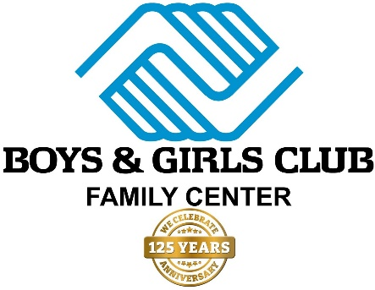
5K Road Race Sponsorship Pledge
BOYS & GIRLS CLUB FAMILY CENTER
SUPPORTING EVENTS & PROGRAMS
FOR YOUTH & FAMILIES
Please respond to the Executive Director, Keshawn Dodds at your earliest convenience. Printed programs for our first event will begin on Monday, September 4, 2023.
We are pleased to support the Boys & Girls Club Family Center as a Major Sponsor at the following level:
$1,000 Event Sponsor $750 Program Sponsor $500 Membership Sponsor

$250 Friend Sponsor $50.00 Gift $25.00 Gift

Business Name: _____________________________________________________________
Contact Name: ______________________________________________________________
Address: ___________________________________________________________________
City: ___________________________________________ State: ________ Zip: __________
Business Phone: _____________________ Mobile: _________________________________
Email: _____________________________________________________________________
Method of Payment: Credit Card Check
Names on Card: _____________________________________________________________
Card #: _________________________________ Exp: ___/____ CCV Code: _____________
Signature: _________________________________________________________________

By signing the above, I pledge the amount indicated above to be paid in full by April 1, 2024. I understand that full payment MUST be turned in to receive the benefits of my sponsorship. A signed form must be returned for the Boys & Girls Club Family Center to accept my pledge.

